## *Name :- Amr Hamdy Mohamed Ali

## **\*Group** :- 5

## **\*Sec** :- 25

## *B.N :- 13

## *Topic :- Artificial Intelligence

### *Application Brief :- AI is the most interesting thing in all world today and it’s the future , It’s  refers to the simulation of human intelligence in machines that are programmed to think like humans and mimic their actions. The term may also be applied to any machine that exhibits traits associated with a human mind such as learning and problem-solving.

### *screenshots :-

### C:\Users\LENOVO\AppData\Local\Microsoft\Windows\INetCache\Content.Word\Screenshot 2021-06-05 145405.png

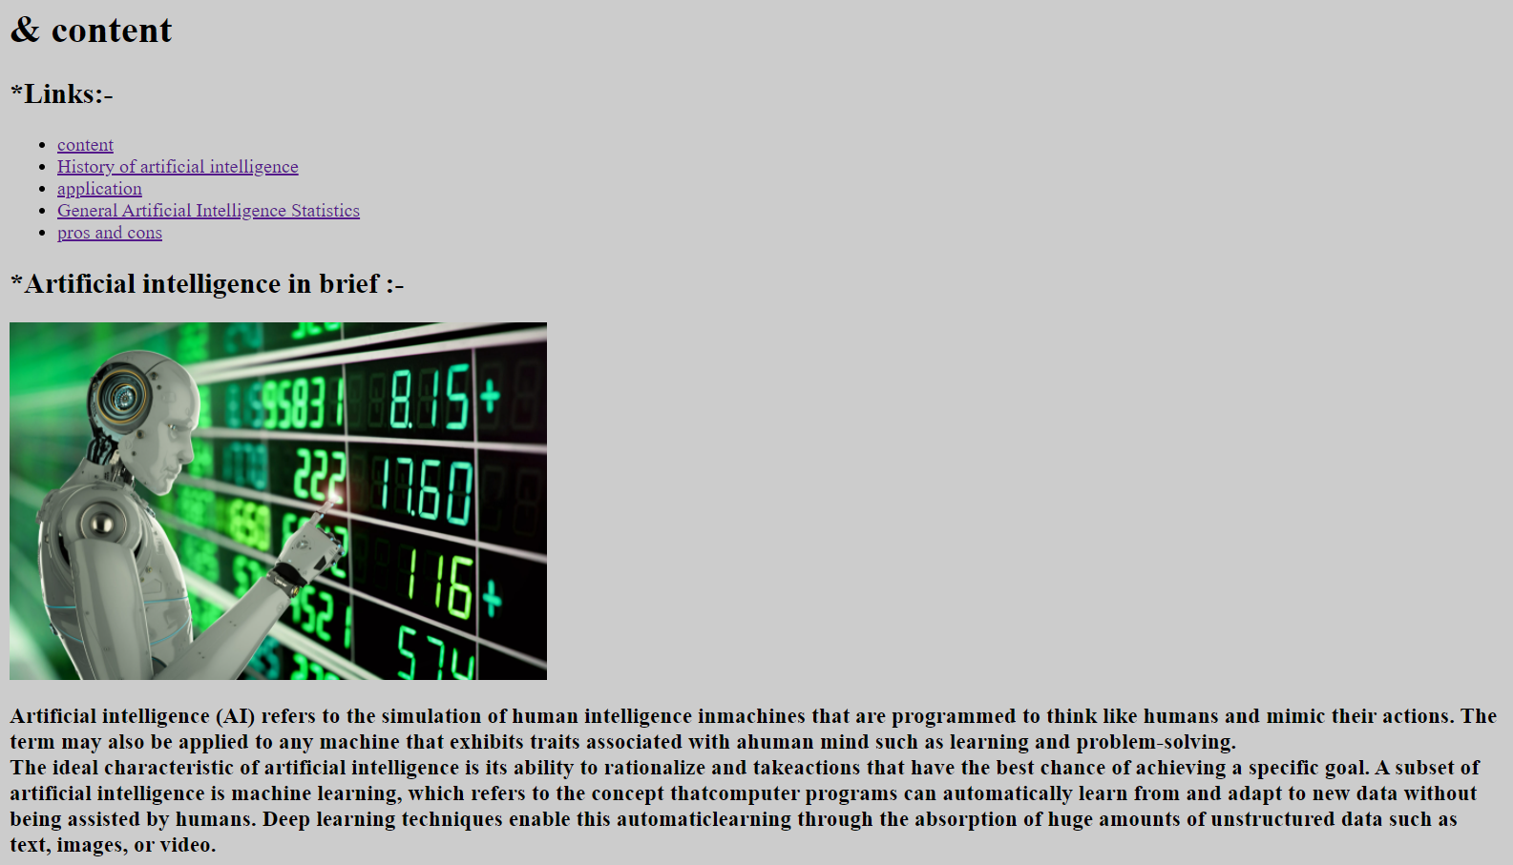

### *Source code :-

### C:\Users\LENOVO\AppData\Local\Microsoft\Windows\INetCache\Content.Word\Screenshot 2021-06-05 145552.png